苹果电脑驱动文件添加安全信任
MAC Drive files Add security trust

1：在系统偏好设置里面，找到“安全性与隐私”选项；
In the system preferences, find the "Security and Privacy" option;

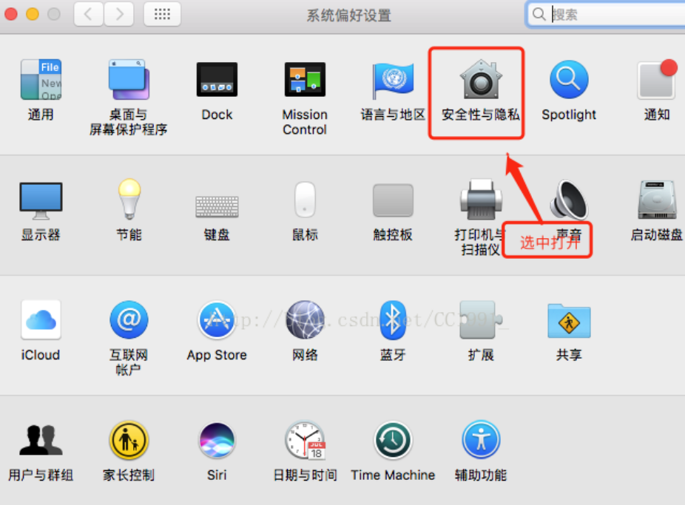
2：在安全性与隐私里面，找到左下角的锁型图标，然后点击锁，会弹出输入电脑开机密码的窗口，输入密码之后，点击“解锁”按钮，那个锁型变为开启的锁；
In the security and privacy, find the lock icon in the lower left corner, and then click the lock, the window will pop up to enter the computer startup password, after entering the password, click the "unlock" button, the lock type becomes the open lock;
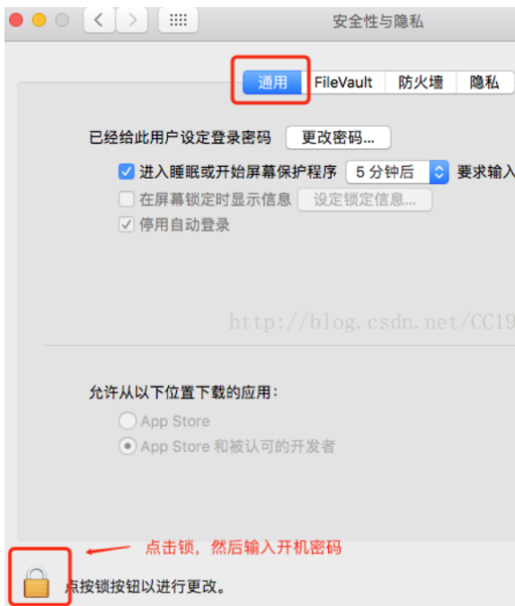
3：解锁后，如果你的电脑里面在允许从以下位置下载应用有三个选项，就在允许从以下位置下载的应用选项中选择“任何来源”，在弹出的确认框里点击“允许来自任何来源”；如果你的电脑里面允许从以下位置下载的应用中只有两个选项，那你就直接去打开你刚才需要安装的那个程序的安装包，双击重新安装，会有一个提示框，也是提示允许来自任何来源安装的，然后就可以安装成功。
After unlocking, if your computer has three options for allowing apps to be downloaded from the following locations, select "Any source" from the options for allowing apps to be downloaded from the following locations and click "Allow from any Source" in the pop-up confirmation box; If there are only two options on your computer that allow you to download applications from the following locations, then you can directly open the installation package of the program you just need to install, double-click to reinstall it, and there will be a prompt box that allows you to install from any source, and then the installation is successful.
